………………………secondary school.  Full name: ............................................  Class: 7……. |  | WRITTEN ENGLISH TEST NO 3.  Time: 45 minutes  Đề tổ hợp
Marks | Remarks
I. LISTENING( 2PTS)
I. Listen and choose the best answer. (1pt)
1.Which book did John buy?  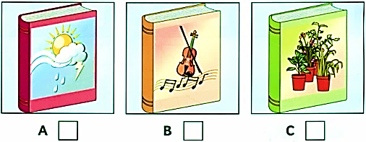 | 2. What does Sally want to do?  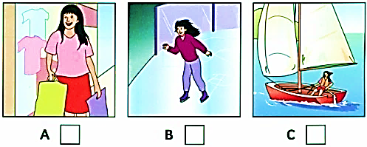 | 3. What’s in the playground?  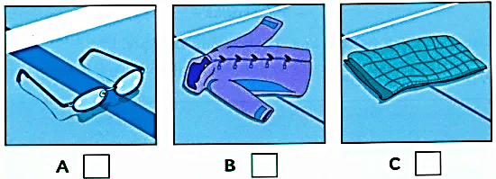
4. What is Ben drawing?  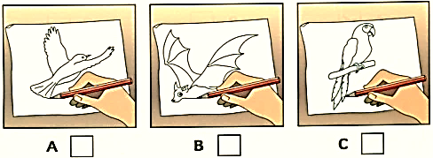 | 5. What is Mum doing?  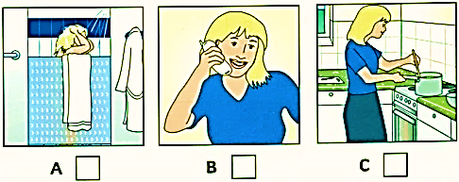

II. Listen and write one missing word for each space below. (1pts)
REDBRIDGE SPORTS CENTRE
0. Name: Lucy Flynn  1. Which class? …………………….  2. When? …………………… | 3. Name of teacher? …………………  4. Comes to Centre by: ……………..  5. Favourite spor: ……………….

B- GRAMMAR- VOCABULARY
Choose A, B or C for each gap in the following sentences (2.0 pts)
1. Lan used to _____ morning exercise when she got up early.
A. did B. does C. do
2. Bus is the main public______in Viet Nam.
A. travel B. tricycle C. transport
3. The play was so boring. ________, Hoa saw it from beginning to end.
A. However B. Therefore C. Despite
4. Which word doesn’t belong in each group:
A. animation B. documentary C. plot
5. Find the word which has a different sound in the past underlined.
A. liked B. washed C. loved
6. _____ is La Tomatina celebrated? – Every August.
A. Where B. Why C.When
7. My father liked the ______ of that singer.
A. perform B. performance C.performer
8. In Viet Nam, people celebrate ______ in late January or early February.
A. Christmas B. Tet holiday C. Thanksgiving
9. A film that shows real life events or stories is called a(n) _________.
A. thriller B. comedy C. documentary
10. Many famous films ____ in Hollywood.
A. are made B. make C. made
C. READING
I. Which notice (A-E) says this (1-5)? Do the matching. ( 1,5ps)
2.  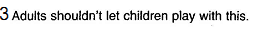  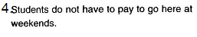  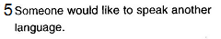 | A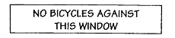  B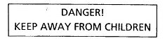  C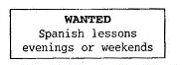  D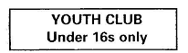  E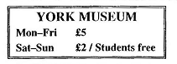
1………. 2. …….... 3………… 4………… 5…………

II. Read the passage, then choose the right answer to the questions below (1.5 pts )
My first visit to the cinema was a very happy one. I was taken there by some friends when I was only eleven years old. At first there were bright lights and music and I felt quite happy. When the lights went out, I felt afraid. Then I saw a train on the screen, the train was coming towards me. I shouted out in fear and got down under my seat. When my friends saw me, they started to laugh. I felt ashamed and sat back in my seat. I was very glad when the film ended
1. Who took the writer to the cinema for the first time?
A. His father B. His parents C.His friends
2. How did he feel at first?
A. happy B. sad C. quite unhappy
3. He was frightened when …….
A. there was music B. the cinemas had no lights C. his friends saw him
4. Where did he hide when he saw the train coming towards him?
A. under his seat B. on the screen C. behind his friend’s back
5. How did he feel when the film finished?
A. very sad B. very unhappy C . very happy
D. WRITTING
I. Rewrite the sentences with the same meaning (1.5pts):
1.. She was tired, but she wanted to do her work.
=> Despite ……….………………………………………………………….……………
2. Mrs Hoa went to work by car, but now she goes by bus.
→ Mrs Hoa used ……………...................................................................................
3. What is the distance between Vinh Phuc and Ha Noi ?
=> How…........................................…………………………………………………..….?
4. The story of the film was good. However, I didn’t like the acting.
-> Although ….................................................................................................................
5. The distance from Chi Linh Town to Ha Long Bay is about 80 km.
-> It …............................................................................................................................

II. Write a short paragraph about a festival you know (including name of the festival, where and when, how long, why and how it is held, feeling, …) (1.5pts).
………………………………………………………………………………………………………………………………………………………………………………………………………………………………………………………………………………………………………………………………………………………………………………………………………………………………………………………………………………………………………………………………………………………………………………………………………………………………………………………………………………………………………………………………………………………………………………………………………………………………………………………………………………………………………………………………………………………………………………………………………………………………………………………………………………………………………………………………………………………………………………………………

ANSWER KEYS FOR TEST NO 3 - 45 MINUTES

Sentences | Answer key | Point
A.  LISTENING (2pts) | I) (1p): Listen and choose the best answer.  1. B 2. A 3. C 4. B 5. A | 5 x 0.2  = 1p
 | II) ( 1p): Listen and write  1. swimming 2. afternoon 3. Hart  4. (her father’s/ dad’s) car 5. tennis | 5 x 0.5  = 1 p
B. VOCABULARY, GRAMMAR AND LANGUAGE FUNCTION | Choose the correct option A, B or C to complete the sentences.  1.C ; 2.C ; 3.A ; 4.C ; 5.A ;  6.C ; 7.B ; 8.B ; 9.C ; 10.A | 10 x 0.2  = 2pts
C. READING  (3pts) | I) ( 1.5pts ). Which notice (A-E) says this (1-5)? Do the matching  1.-D ; 2.-A ; 3.-B ; 4.-E ; 5.C | 5 x 0.3  = 1.5pts
 | II) ( 1.5pts ): . Read the passage, then choose the right answer to the questions below  1. C ; 2. A ; 3. B ; 4. B; 5. C | 5 x 0.3  = 1.5 pts
D. WRITING  ( 3 pts) | I) ( 1.5 pts ) . Rewrite the sentences with the same meaning.  1. Despite being tired, she wanted to do her work .  2. Mrs Hoa used to go to work by car, but now she goes by bus.  3. How far is it from Vinh Phuc to Ha Noi?  4. Although the story of the film was good, I didn’t like the acting.  5. It is about 80 km from Chi Linh town to Ha Long Bay | 5 x 0.3  = 1.5 pts
 | II) ( 1.5 pts ). Write a paragraph.  - Name of the festival: (0.1 pt)  - where and when :(0.5 pts)  - how long: (0.2 pts)  - why and how it is held: (0.5 pts)  - feeling: (0.2 pts)  + Notes:  - Bài viết:  Nếu sai ngữ pháp câu nào không cho điểm câu đó.  Nếu sai chính tả 2 lỗi không cho điểm câu đó.  - Với tất cả các bài:  Nếu thấy học sinh làm theo cách khác mà đúng, vẫn cho điểm tối đa.  Example writing:  The festival I have attended recently is Tet. Tet is a seasonal festival. It was held everywhere in Vietnam in January of the Lunar year. During Tet, Vietnamese people did not go to work. They decorated and cleaned their houses. They also bought many kinds of food, drinks or new clothes for children and celebrated the New Year with their families. They wrapped the sticky rice cakes and spring rolls on Tet. Tet is for Vietnamese people to say goodbye the previous year, celebrate the New Year and wish good luck to everyone. I feel very fantastic/ happy about Tet. | 1.5 pts

Nếu sai 2 lỗi (chính tả, giới từ, động từ,…) trở lên trong một câu thì không tính điểm của câu đó.
- Học sinh làm theo cách khác, giám khảo xem xét nếu thấy đúng vẫn cho điểm tối đa.

